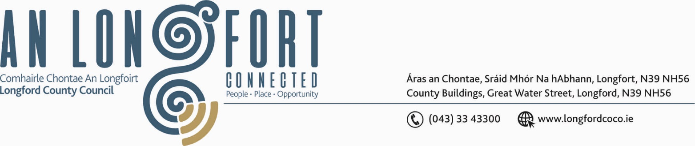

LONGFORD MUNICIPAL DISTRICT

Please note venue and time of meeting.

17th September 2020.

To: Each Member of Longford Municipal District.

Dear Member,

You are requested to attend Meeting of Longford Municipal District to be, held in
Longford Rugby Club, Demesne, Longford on Wednesday, 23rd September 2020 at
4.30 p.m. to transact business, as set out on the Agenda hereunder.

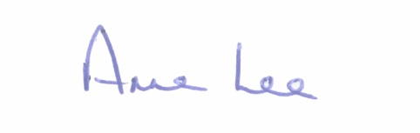
Yours sincerely,

_______________
Anne Lee,
Meetings Administrator.

AGENDA

Prayer before meeting.

- Confirmation of Minutes of meetings of Longford Municipal District held on
the 22nd July 2020 - copy enclosed

- Matters arising from Minutes.

- Declaration of Interest by Members.

- Management Report - enclosed.

- Update on Ballymacormack Cemetery Collabrium Wall.

- Consideration of applications for funding under the 2020 Community Grant Support
Scheme.

- Notices of Motions, submitted by Councillors, as listed hereunder –

Councillor Uruemu Adejinmi.

“I call on Longford Municipal District to carry out a Low Cost Safety Scheme on the
Knockloughlin Road to tackle speeding and the blind corner at Knockloughlin in the
direction of Melview cross which is a safety hazard and I’m told that over the years there
have been a number of collisions.”

Councillor Seamus Butler.

“That the lane off Chapel Street that serves the rear of several premises on Dublin St,
including a Pharmacy, be taken in charge and/or be resurfaced by the Longford Municipal
District of Longford County Council. Similarly, the lane at the rear of St Mary’s Terrace,
Dublin Road.”

- Correspondence – enclosed.
- Correspondence received from Féileacáin (Stillbirth and Neonatal Death
Association of Ireland) regarding “Wave of Light” campaign on the 15th October.



